**Deliverable 3**

**Introduction**

The NYC311 dataset is a valuable resource that contains information about service requests from New York City residents. This data covers a wide range of complaints and service requests, including noise complaints, public assistance requests, reports of infrastructure problems, and more. The dataset is maintained by the New York City government and is used to track and address various concerns of the city's residents.

This project aims to analyze the NYC311 data to understand the impact of two significant events on New York City: Hurricane Sandy and the COVID-19 pandemic. By examining the volume and types of service requests before, during and after these events, we can gain insight into the impact of these events on the city's residents and infrastructure.

The primary questions this analysis seeks to answer are:

1. **How did Hurricane Sandy impact New York City base on NYC311 data?**
2. **What was the impact of COVID-19 on New York City based on NYC311 data?**

Analysis involves summarizing and visualizing the data to identify patterns and trends related to these events. By comparing service requests before and after these events, identifying common complaint types, mapping affected areas, and analyzing the agencies with the highest number of requests, we aim to provide a comprehensive understanding of the impact of Hurricane Sandy and COVID-19 on New York City.

**Data Collection Process**

Data Source

The NYC311 dataset is publicly available and maintained by the New York City government. It contains detailed information about service requests from residents across the city. The data is accessible through the NYC Open Data Portal, which provides a wealth of information on various city-related data points.

Data Filtering

For the purpose of this analysis, the dataset was filtered to focus on two specific time frames:

1. Hurricane Sandy: Hurricane Sandy made landfall in New York City on October 29, 2012, and its immediate aftermath lasted for several weeks. The analysis focuses on service requests from October 22, 2012, to November 12, 2012, to capture the period before, during, and after the hurricane.
2. COVID-19 Pandemic: The COVID-19 pandemic significantly affected New York City starting in early 2020. For this analysis, the period from March 1, 2020, onwards was considered to capture the impact of the pandemic.

The dataset was filtered using the following criteria:

* Hurricane Sandy Time Frame: Data from October 22, 2012, to November 12, 2012.
* COVID-19 Time Frame: Data from March 1, 2020, onwards.

These time frames were chosen to ensure a clear comparison of service requests before, during, and after these events. The filtered data was then used for further preprocessing and analysis.

**Data Summary and Visualization**

*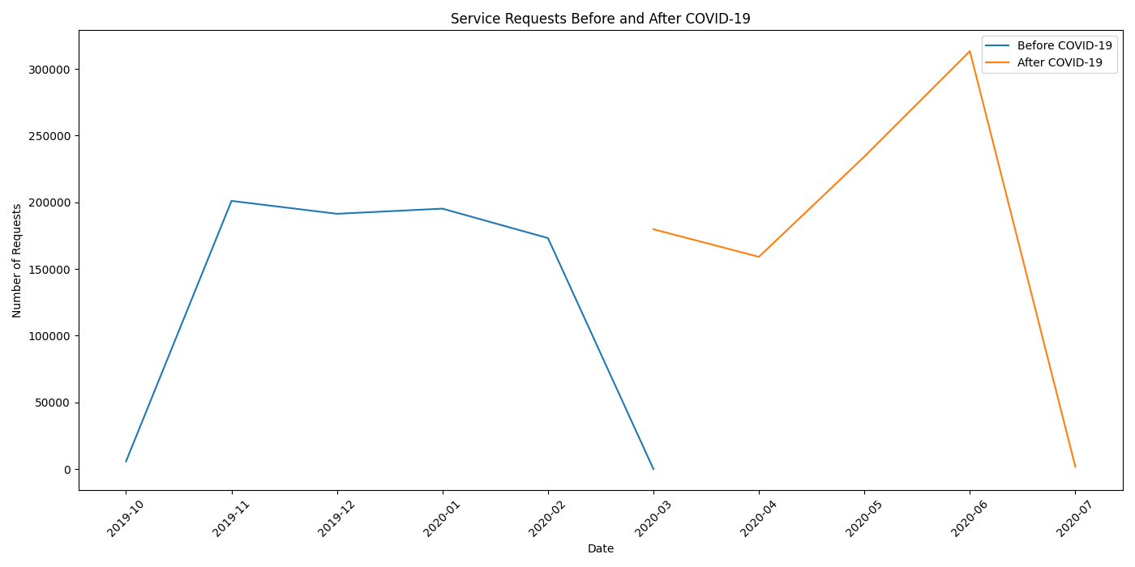Services Requests Before and After COVID-19*

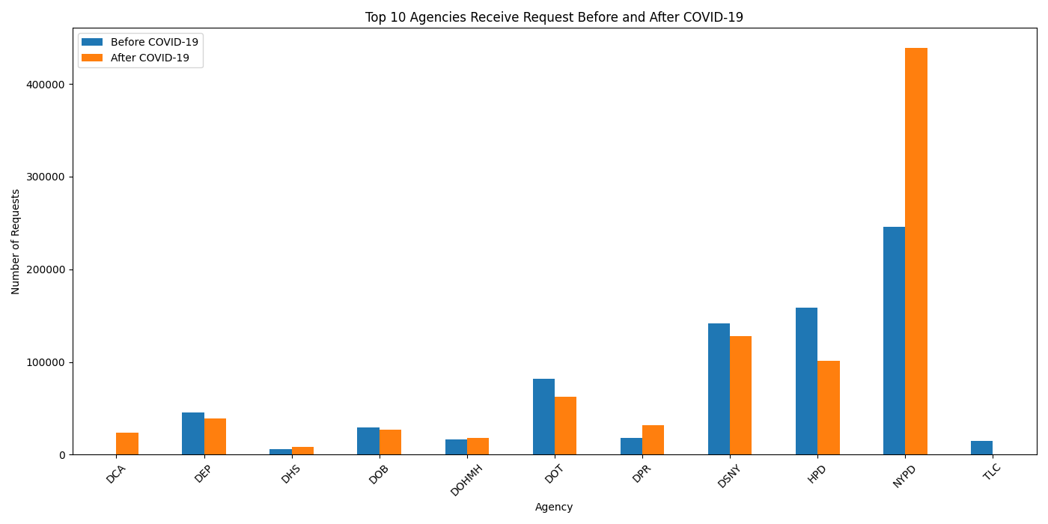*Top 10 Agencies Receive Request Before and After COVID-19*

*Top 10 Complaint Types Before and After COVID-19*

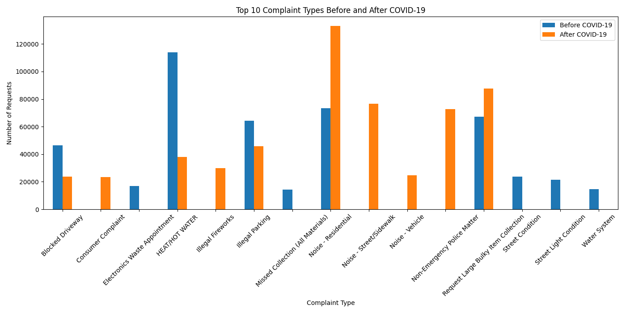

*Top 10 Zip Code Areas Call a Request Before and After COVID-19*

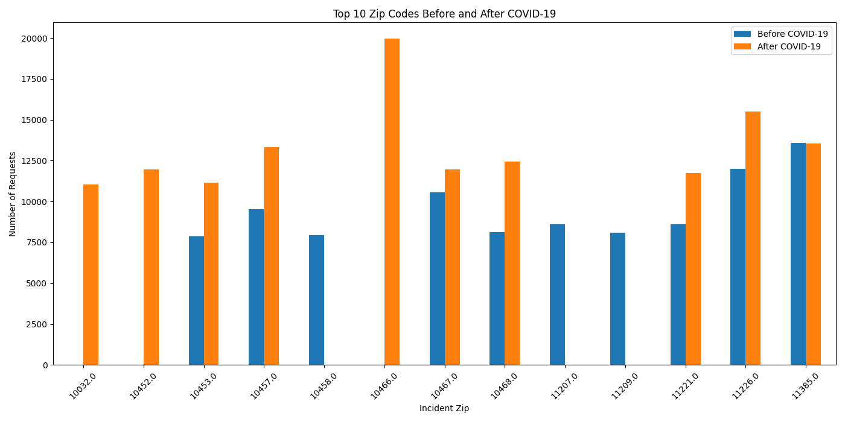

*Services Requests Before and After Hurricane Sandy*

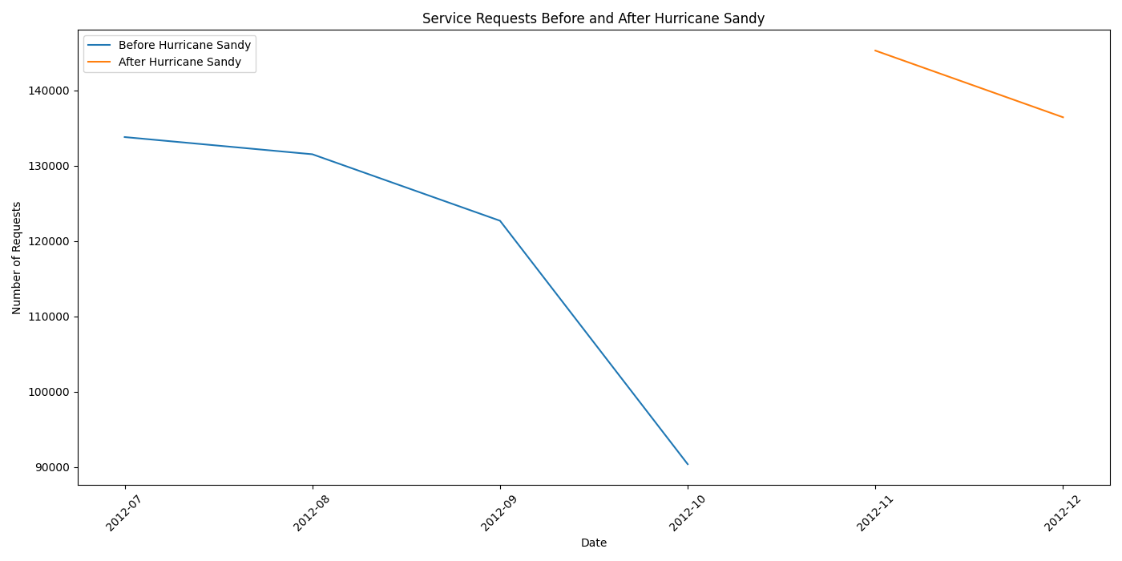

*Top 10 Agencies Receive Request Before and After Hurricane Sandy*

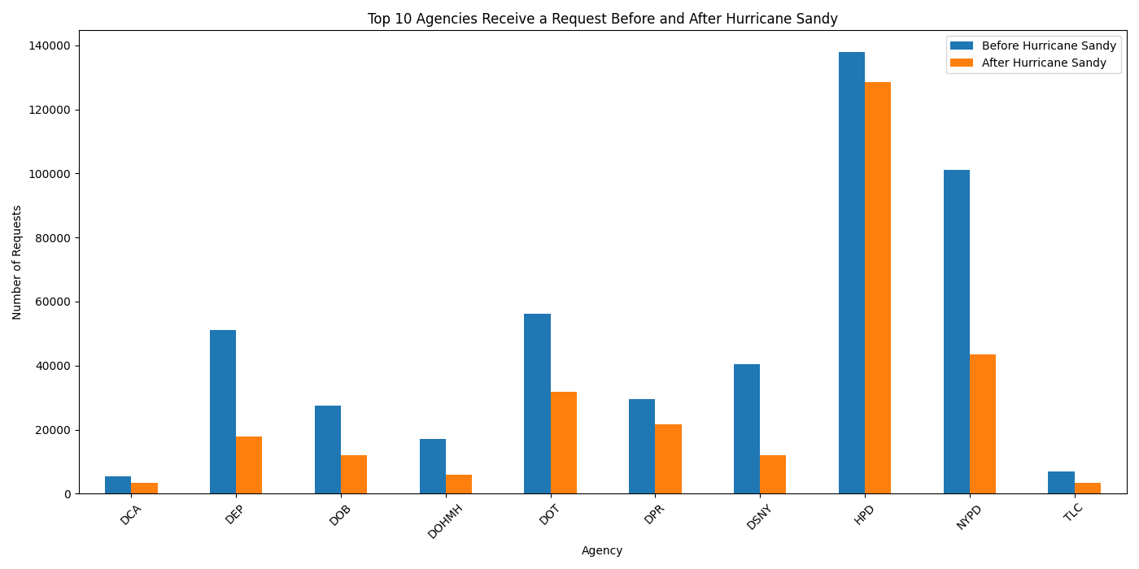

*Top 10 Complaint Types Before and After Hurricane Sandy*

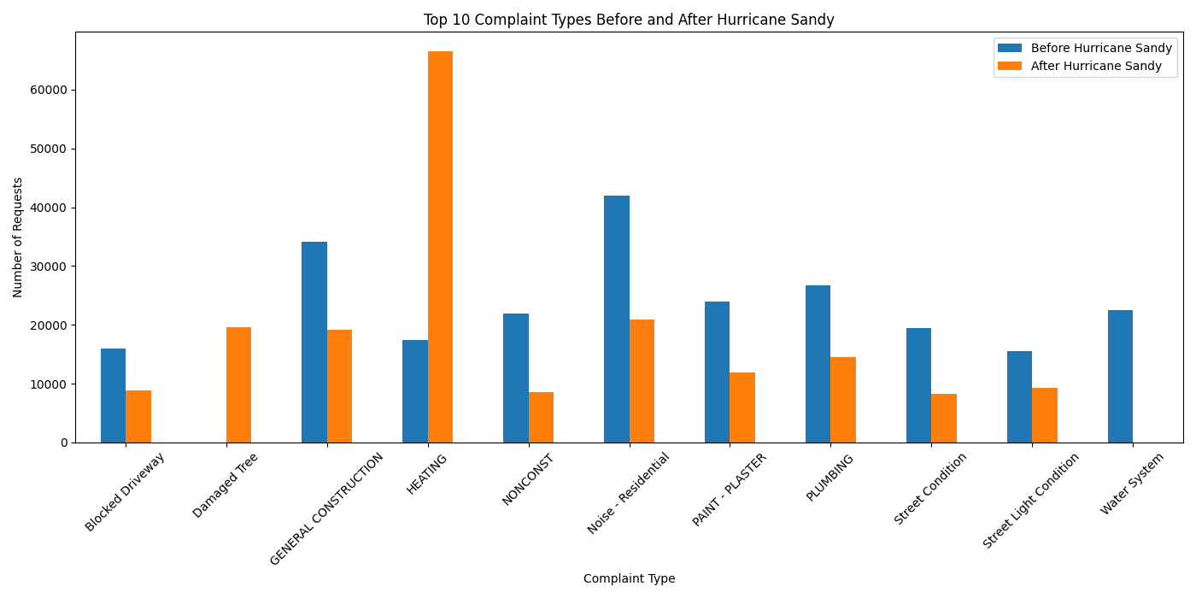

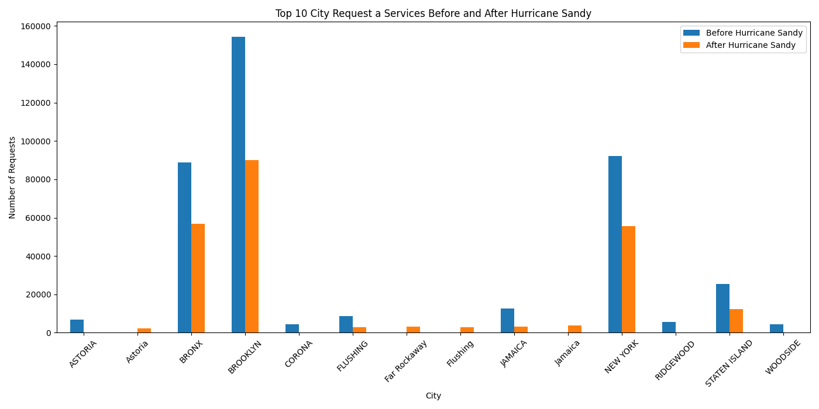*Top 10 City Call a Request Before and After Hurricane Sandy*

**Data Analysis**

1. Impact of COVID-19 on Service Requests

* Requests Before and After COVID-19 - The data shows a sharp decline in the number of service requests from February 2020 to March 2020, reflecting the onset of COVID-19. Before the pandemic, service requests were relatively high and stable, with a peak in January 2020. After March 2020, there was a significant increase in requests, peaking in June 2020, indicating a surge in demand possibly due to the pandemic's impact on various services.
* Common Complaint Types Before and After COVID-19 - Before COVID-19, the most common complaints were related to heating issues, residential noise, bulky item collection, and parking violations. After COVID-19, there was a notable shift in complaint types with a significant increase in noise-related issues, particularly street/sidewalk noise, and non-emergency police matters. The decrease in heating complaints and an increase in complaints about illegal fireworks suggest a change in public concerns during the pandemic.
* Identifying Agencies with the Highest Requests - Before COVID-19, the top agencies receiving requests were NYPD, HPD, and DSNY. Post-pandemic, while NYPD still received the highest number of requests, there was a notable increase in requests to DSNY and a decrease in those to HPD. This shift might indicate changes in public service demands and agency workload due to the pandemic.
* Analyzing Areas with Most Complaints Before and After COVID-19 - Before COVID-19, the zip codes with the highest number of complaints included 11385, 11226, and 10467. After COVID-19, these areas remained among the top, with some shifts in ranking and an increase in complaints in other areas like 10466 and 10452. This analysis highlights which neighborhoods saw increased service demands during the pandemic and could be useful for targeting resource allocation.

1. Impact of Hurricane Sandy on Service Requests

* Requests Before and After Hurricane Sandy - The data indicates a significant increase in service requests in the months following Hurricane Sandy. Before the hurricane, service requests were relatively high but showed a drop in October 2012. After the hurricane hit in late October 2012, there was a substantial increase in service requests in November and December 2012, reflecting the urgent need for repairs and assistance post-disaster.
* Common Complaint Types Before and After Hurricane Sandy - Before Hurricane Sandy, common complaints were related to residential noise, general construction issues, plumbing, and street conditions. After the hurricane, there was a marked shift with a dramatic increase in heating issues, damaged trees, and general construction complaints. This shift highlights the immediate concerns for heating and infrastructure repairs in the aftermath of the hurricane.
* Identifying Agencies with the Highest Requests - Before Hurricane Sandy, the top agencies receiving service requests were HPD, NYPD, and DOT. After the hurricane, HPD remained the top agency, but there was a notable decrease in requests to NYPD and DOT, while other agencies like DPR and DSNY saw increased requests. This shift suggests a change in the focus of service needs from emergency response to infrastructure repair and recovery.
* Analyzing Areas with Most Complaints Before and After Hurricane Sandy - Before Hurricane Sandy, Brooklyn, New York, and the Bronx had the highest number of service requests. After the hurricane, Brooklyn continued to be the area with the most requests, but there was a noticeable increase in complaints in areas like Far Rockaway and a decrease in complaints from other neighborhoods such as Flushing and Jamaica. This shift reflects the hurricane's varying impact across different parts of the city.

**Results and Discussion**

1. COVID-19:

* The COVID-19 pandemic significantly impacted the volume and nature of service requests in New York City. The dramatic rise in requests following the onset of the pandemic suggests increased public needs, while the shift in complaint types reveals changing concerns, from noise to non-emergency police matters. The variation in agency requests and affected areas further illustrates how different aspects of city services were impacted by the pandemic.

2.Hurricane Sandy

* The analysis of service requests before and after Hurricane Sandy shows a significant increase in demand immediately following the hurricane, indicating a strong need for emergency services and repairs. The shift in complaint types to heating issues and damaged trees highlights the immediate infrastructure and utility concerns faced by residents post-disaster. The changes in agency workloads and the geographic distribution of complaints provide valuable insights into the hurricane's impact on different areas of New York City, helping to assess the effectiveness of the response and recovery efforts.